Exercise 1: Logging Error Messages and Warning Levels
Step 1: Add SLF4J and Logback dependencies in pom.xml
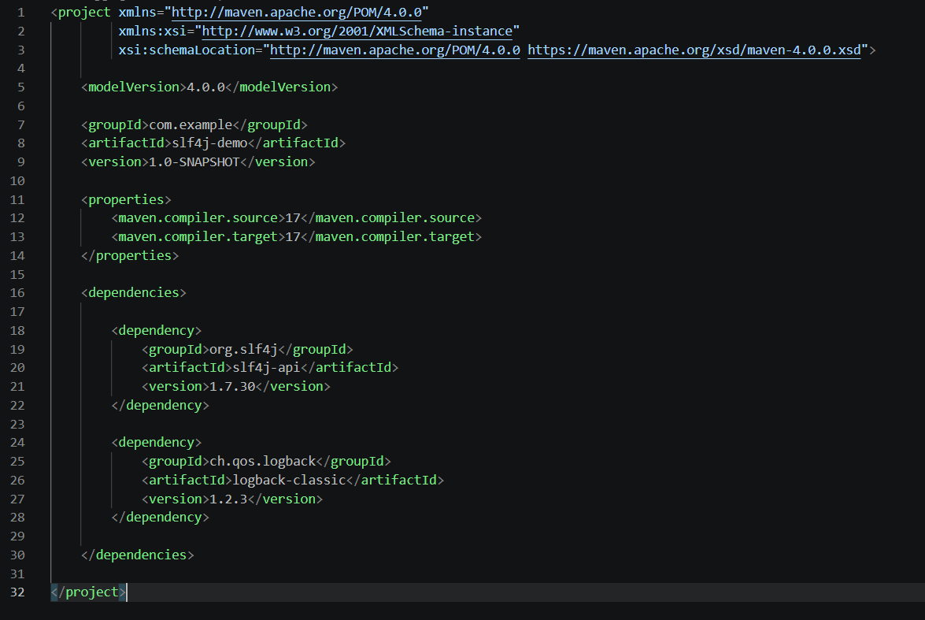
Step 2: Create LoggingExample.java
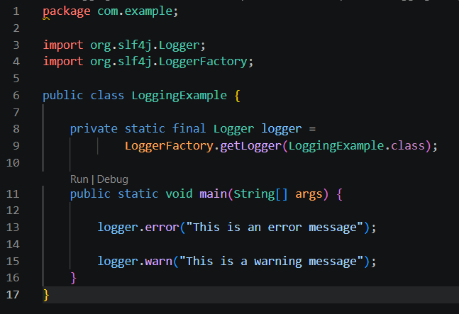
Step 3: Execute the application
Run Command
mvn exec:java -Dexec.mainClass=com.example.LoggingExample
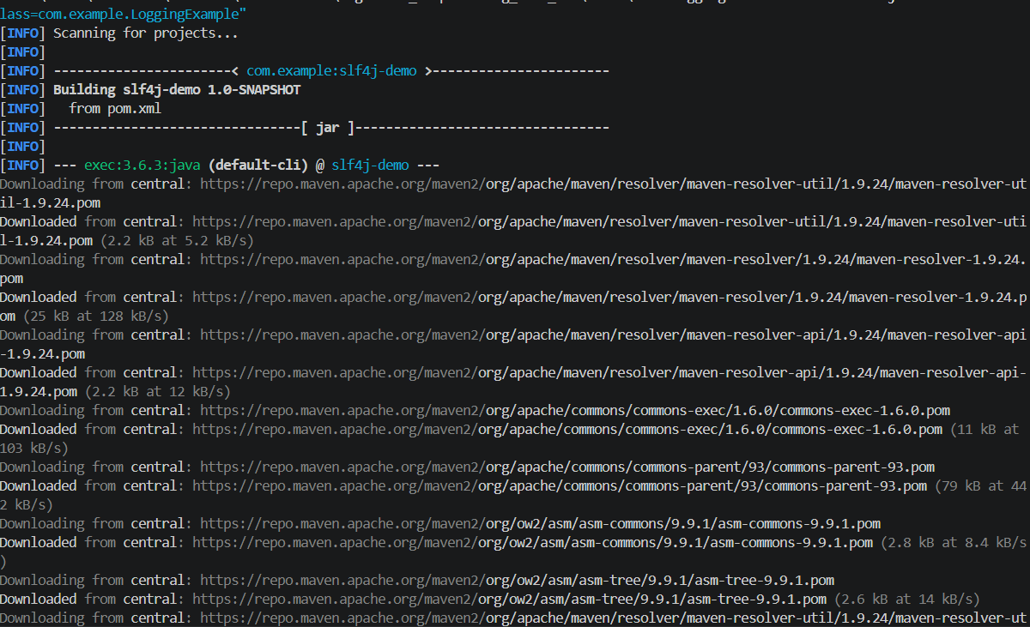

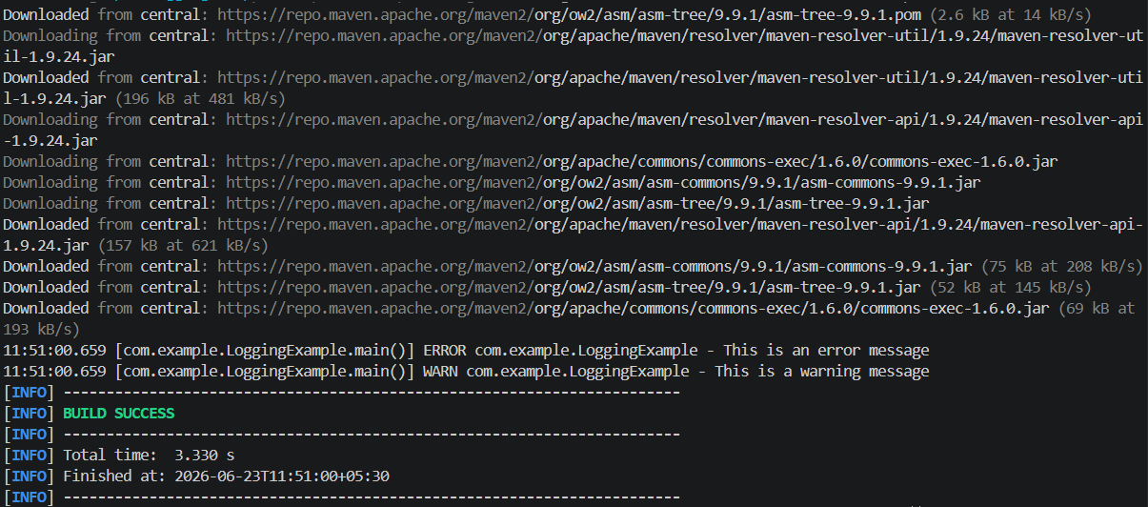
Result:
The application successfully demonstrated logging using SLF4J. Error and warning messages were logged and displayed successfully.

